**Experiment No: 1**

**Aim:** Write a Python program to read a file line by line and store it into a list.

**CO5:** Create files and form regular expressions for effective search operations on strings and

files.

**Procedure:**

#To read the file content and store it into a list  
#CO5  
open_file = open('co5prgrm.txt', 'r')  
File_Lines =open_file.readlines()  
  
  
  
#without using strip  
print("\nFile content with newline charecter:")  
print(File_Lines)  
  
# using strip  
print("\nfile content after removing newline charecter:")  
File_Lines = [x.strip() for x in File_Lines]  
print([x.strip() for x in File_Lines])open_file.close()

// here we also need to create a txt file //

**Output Screenshot:**

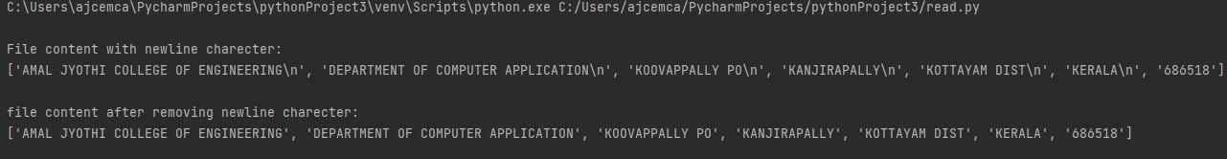

**Result:** The program was executed and the result was successfully obtained. Thus CO5 was obtained.

**Experiment No: 2**

**Aim:** Python program to copy odd lines of one file to other.

**CO5:** Create files and form regular expressions for effective search operations on strings and files.

**Procedure:**

#program tp copy odd lines of the file to another  
#opening files for reading and writing data  
input_file =open ('data.txt')  
output_file = open ('writedata.txt', 'w')  
  
#copying/reading contents from read_file to copy_data  
copy_data = input_file.readlines()  
print("\nactual file content is:")  
print(copy_data, "\n")  
  
for i in range(0, len(copy_data)):  
 if i % 2 == 0:  
 output_file.write(copy_data[i])  
 else:  
 pass  
  
#closing files after writting  
output_file.close()  
  
#opening write file in read mode and printing values  
output_file = open('writedata.txt', 'r')  
print("odd lines are:")  
print(output_file.read())  
  
#closing files  
input_file.close()  
output_file.close()

**Output Screenshot:**

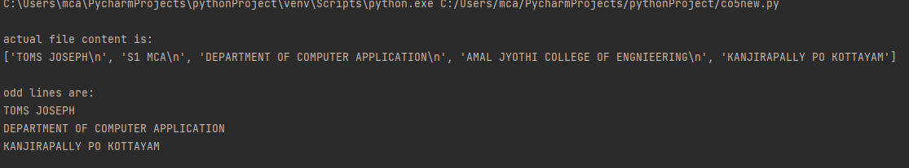

**Result:** The program was executed and the result was successfully obtained. Thus CO5 was obtained

**Experiment No: 3**

**Aim:** Write a Python program to read each row from a given csv file and

print a list of strings.

**CO5:** Create files and form regular expressions for effective search operations on strings and files.

**Procedure:**

import csv  
  
#open the csv file  
with open('pythontxt.csv', 'r')as file:  
 #create a csv reader  
 reader=csv.reader(file)  
  
 #iterate ober the rows of the csv file  
 for row in reader:  
 #print the row as a list of strings  
 print(row

**Output Screenshot:**

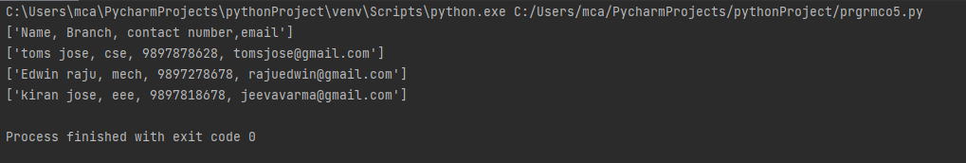

**Result:** The program was executed and the result was successfully obtained. Thus CO5 was obtained

**Experiment No: 4**

**Aim:** Write a Python program to read specific columns of a given CSV file

and print the content of the columns.

**CO5:** Create files and form regular expressions for effective search operations on strings and files.

**Procedure:**

# Program to read specific columns of a given CSV file and print the content

import csv

# specify the column indices that you want to read

columns_to_read = [0, 2]

# open the CSV file and read the contents

with open('Book.csv', 'r') as f:

#create a csv reader

reader = csv.reader(f)

# iterate over the rows of the CSV file

for row in reader:

# print the contents of the specified columns

print([row[i] for i in columns_to_read])

**Output Screenshot:**

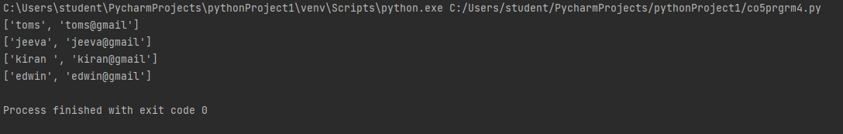

**Result:** The program was executed and the result was successfully obtained. Thus CO5 was obtained

**Experiment No: 5**

**Aim:** Write a Python program to write a Python dictionary to a csv file. After writing the CSV file read the CSV file and display the content.

**CO5:** Create files and form regular expressions for effective search operations on strings and files.

**Procedure:**

# Write a Python program to write a Python dictionary to a csv file.

# After writing the CSV file read the CSV file and display the content.

import csv

# Data to be inserted

data = [{'Name': 'toms', 'Age': 25, 'Country': 'United States'},

{'Name': 'sougand', 'Age': 32, 'Country': 'Canada'},

{'Name': 'jeeva', 'Age': 35, 'Country': 'United Kingdom'}]

# Write to CSV file

with open('people.csv', 'w') as csvfile:

headernames = ['Name', 'Age', 'Country']

csvwriter = csv.DictWriter(csvfile, fieldnames=headernames)

csvwriter.writeheader()

for row in data:

csvwriter.writerow(row)

# Read from CSV file and print contents

with open('people.csv', 'r') as csvfile:

reader = csv.DictReader(csvfile)

for row in reader:

print(row)

**Output Screenshot:**

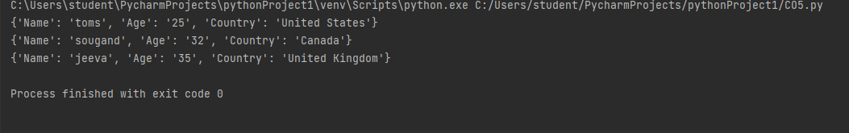

**Result:** The program was executed and the result was successfully obtained. Thus CO5 was obtained